Write a class ACCOUNT that represents your bank account then use it. The class should allow you to deposit money, withdraw money, calculate interest, send you a message if you have insufficient balance.
Bank Account
Assignment - 5
Rudra Chinhara

GITHUB LINK
CODE
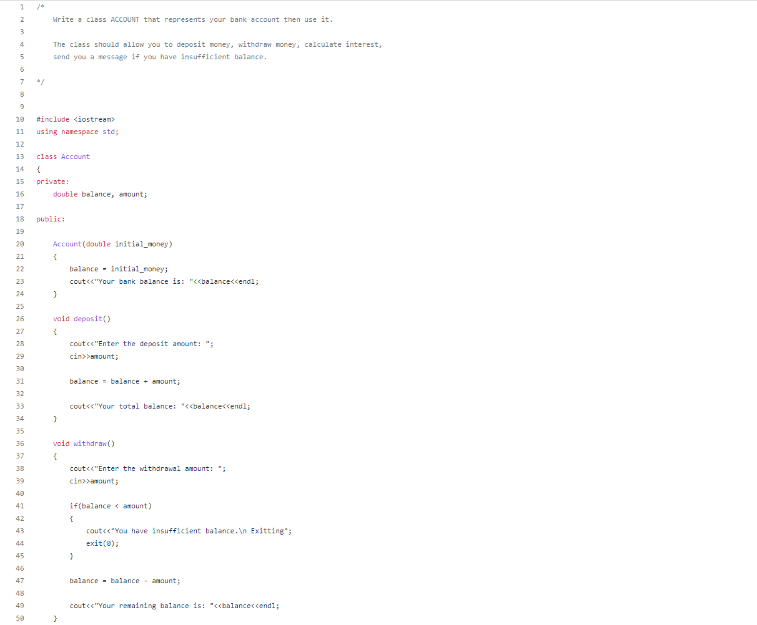
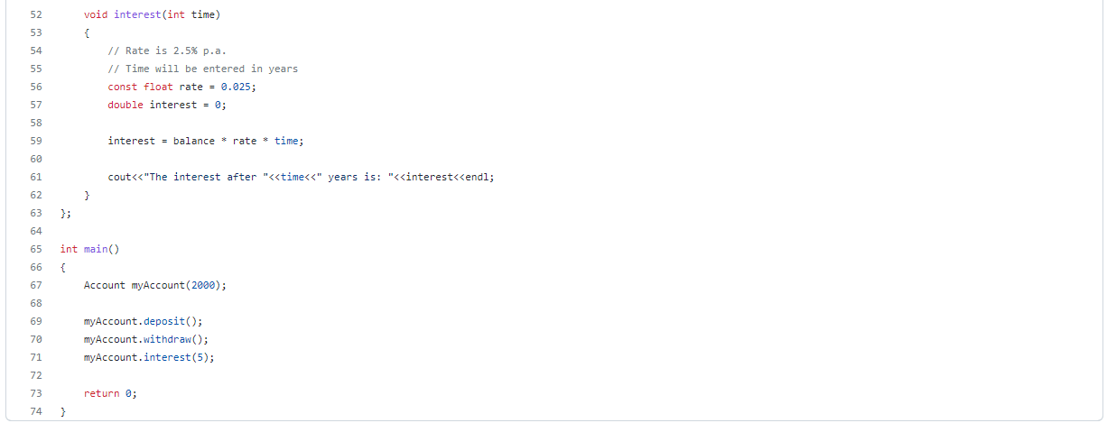
OUTPUT
